DATELINE: FOR IMMEDIATE RELEASE

BOWLING’S EXCITING NEW FORMAT LAUNCHED

The “Bowling Bash” – an exciting new format for beginners and experienced players alike - is to be launched on the bowling green in Central Park in Syston on Saturday 22nd April starting at 2.00 p.m.
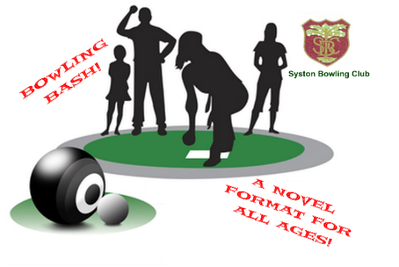
Cricket has its T20. Bowling has now developed a similarly exciting short-form format to attract more players to what is quite wrongly identified as a game reserved for the older generation.

The game is suited to all ages and genders. Each game lasts no more than an hour. Participation is free of charge and no special equipment – other than footwear without heels - is required. The clubhouse Bar will be open for players and spectators.

A warm welcome is offered to all. Simply turn up and enjoy the challenge. Meet new friends. Learn a new skill.

oooOOOENDOOOooo
Notes to Editor: For further information about this Release please contact:
Colin Grimes, Development Director, Syston Bowling Club
T: 0116 2608412 E: systonbowling@btinternet.com

