DATELINE: FOR IMMEDIATE RELEASE

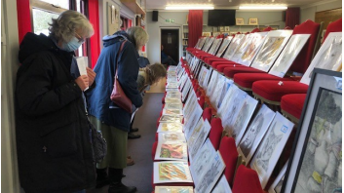
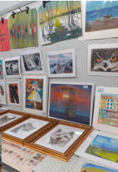
BOWLING CLUB ART GROUP EXHIBITION SUCCESS
The Art Group of the Syston Bowling Group, led by Pauline Wright, held an exhibition in the Clubhouse on 31st March and 1st April.
In spite of the damp weather, the event attracted a steady flow of visitors, family members and friends, all of whom obviously enjoyed the opportunity to socialise and appraise the work of the many exhibitors produced during their fortnightly sessions held throughout the Winter months.
Many of the exhibits we snapped up and, at the close of business, the Group were able to present just over £1000 to the Club Finance Director.
Club Chairman, Dave Anderton, said: Special thanks are due to Pauline for inspiring and unlocking the artistic potential of our Members, many of whom had not previously realised what talent they had. I know that the regular classes have given a great deal of pleasure and satisfaction. Thanks also to those members who worked hard to mount the exhibition itself.
The significant contribution made to Club funds is especially welcome at this time of generally increasing costs.”

oooOOOENDOOOooo
Notes to Editor: For further information about this Release please contact:
Colin Grimes, Development Director/PRO, Syston Bowling Club
T: 0116 2608412 E: systonbowling@btinternet.com
Web site: www.systonbowlingclub.org

